[5]

# 1

[display] 11pt

## 1

11pt

# 2

0pt0pt15pt

## 1

0pt3.5ex plus 1ex minus .2ex2.3ex plus .2ex language=Matlabbreaklinesextendedchars=false

00

1

International Journal of Fatigue

Ma Zepeng et al.

proeng

sort compress

[a]Laboratory of Solid Mechanics, Ecole Polytechnique, 91128 Palaiseau Cedex, France [b]Laboratory of Solid Mechanics, Ecole Polytechnique, 91128 Palaiseau Cedex, France [c]IMSIA, ENSTA ParisTech, CNRS, CEA, EDF, Universit茅 Paris-Saclay, 828 bd des Mar茅chaux, 91762 Palaiseau cedex France

The object of this paper is to propose an energy based fatigue approach which takes into account impurities and hardness in the material which affect the fatigue life while handling multidimensional time varying loading histories.

Our fundamental thought is to assume that the local dissipated energy at small scale governs fatigue at failure. The proposal of our model is to consider a plastic behavior at the mesoscopic scale with a dependence of the yield function not only on the deviatoric part of the stress but also on the hydro static part. A kinematic hardening under the assumptions of associative plasticity is also considered. We follow the Dang Van paradigm. The structure is elastic at the macroscopic scale. At each material points, there is a stochastic distribution of weak points which will undergo strong plastic yielding, which contribute to energy dissipation without affecting the overall macroscopic stress.

Instead of using the number of cycles, we use the concept of loading time. To elaborate real life loading history more accurately, mean stress effect is taken into account in mesoscopic yield function and non-linear damage accumulation law are also considered in our model. Fatigue will then be determined from the plastic shakedown cycle and from a phenomenological fatigue law linking lifetime and accumulated mesoscopic plastic dissipation.

Fatigue; Energy; High cycle; Plasticity; Mean stress

[cor1]Corresponding author. Tel.: +33-634435338

Email address: zepeng.ma@polytechnique.edu

**Nomenclature**

|  |  |  |  |  |
| --- | --- | --- | --- | --- |
|  | maximum deviatoric stress during the loading cycles |  |  |  |
|  | mean stress |  |  |  |
|  | fatigue limit for fully reversed condition |  |  |  |
|  | back stress |  |  |  |
|  | energy dissipation rate at a certain scale |  |  |  |
|  | energy dissipation rate at all scales |  |  |  |
|  | dissipated energy |  |  |  |
|  | dissipated energy per cycle |  |  |  |
|  | current number of cycles |  |  |  |
|  | number of cycles to failure |  |  |  |
|  | rate of effective plastic strain |  |  |  |
|  | accumulated plastic strain rate given as |  |  |  |
|  | dissipated energy to failure per unit volume |  |  |  |
|  | Young’s modulus |  |  |  |
|  | hardening parameter |  |  |  |
|  | weakening scales distribution exponent |  |  |  |
|  | material parameter from Chaboche law(Wohler curve exponent) |  |  |  |
|  | characterizes non-linearity of damage accumulation |  |  |  |
|  | material parameter from Chaboche law |  |  |  |
|  | macroscopic yield stress(normal or shear) |  |  |  |
|  | hydrostatic pressure sensitivity |  |  |  |
|  | deviatoric part of the stress tensor |  |  |  |
|  | macroscopic hydrostatic pressure |  |  |  |
|  | the amplitude of octahedral shear stress |  |  |  |
|  | Von Mises stress |  |  |  |
|  | tensile fatigue limit for |  |  |  |
|  | Macaulay bracket symbol.  is defined as  if |

## 2 Weakening scales and yield function

### 2.1 The concept of weakening scales

We follow the Dan Van paradigm. The structure is elastic at the macroscopic scale. At each material points, there is a stochastic distribution of weak points which will undergo strong plastic yielding, without contributing to the overall macroscopic stress. From a microscopic point of view, there is a distribution of weakening scales, namely . Let  be the macroscopic stress intensity at present time. Let  be the yield limit before weakening. Then we imagine that:

 For , then , the material stays in the elastic regime and there is no energy dissipation at this scale.

 For , then , the material is in the plastic regime and there is dissipated energy at scale s.

### 2.2 Distribution of weakening scales

We assume the weakening scales have a probability distribution of power law:



where  is a material constant and  is hardening constant. The choice of a power law has two reasons : on one hand, this type of distribution correspond to a scale invariant process, on the other hand it should lead in cyclic loading to a prediction of a number of cycles to life limit as a power law function of the stress intensity. More general laws can also be proposed.

At each scale  of a plastic evolution process there is a weakened yield limit , zero initial plastic strain  and zero initial backstress  at initial time . The integrated probability ranging from macroscopic to microscopic stress weakened factor is unit. From this we can conclude:



Then we know , so the distribution is given by:



and it is shown in 1

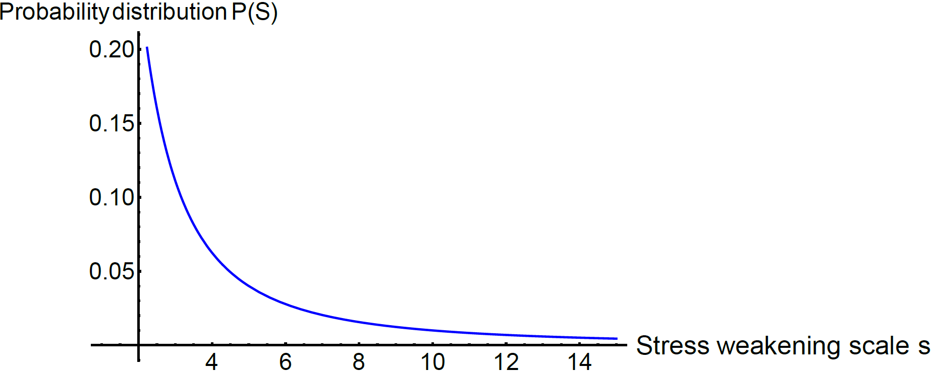

Figure 1: Weakening scales  probability distribution curve

### 2.3 Yield function with mean stress effect

Positive mean stress clearly reduces the fatigue life of the material. In design evaluation of multiaxial fatigue with mean stress, a simplified, conservative relation between mean stress and equivalent alternating stress is necessary. We can improve the model by modifying the yield function  and the localization tensor.

The idea is to consider as in Maitournam and Krebs[3] that the yield limit  can be reduced in presence of positive mean stress. The proposal of this model is to account a plastic material behavior at the micro-scale with a dependence of the yield function on the mean stress . A kinematic hardening under the assumptions of associative plasticity is also considered. The mesoscopic yield function can therefore be written as:

 (1)

with  denoting the deviatoric part of the stress tensor at microscale, and  the corresponding backstress at the same scale.

### 2.4 Local plastic model

First we should describe the mesoscopic stress state. The proposal of this model is to consider a plastic behavior at the mesoscopic scale with a dependence of the yield function not only on the deviatoric part of the stress but also on the hydrostatic part. The mesoscopic evolution equations are thus:

•  Taylor-Lin scale transition model with unit localization tensor[1].

•  kinematic hardening model.

•  plastic flow rule assuming  when  and  when .

Here E denotes the Young’s modulus and k the hardening parameter. The local dissipated energy rate per volume at weakening scales  is given by:

 (2)

## 3 Construction of an energy based fatigue approach

In a preliminary step, we will consider a simple macroscopic loading history  which is uniaxial and time periodic of amplitude , and a Von Mises flow rule without hardening to see if we get a prediction of local failure for a number of cycles  varying as 

In uniaxial cyclic loading, there will be 3 kinds of loading patterns, as is shown in 2 :

1. Elastic regime, in phase 2 and 4, there is  , then 

2. Plastic regime according to plastic flow rule, with increasing plastic deformation, in phase 5 and 1, there is  with  , then  and 

3. Plastic regime in the other direction, in phase 3, there is , then  and 

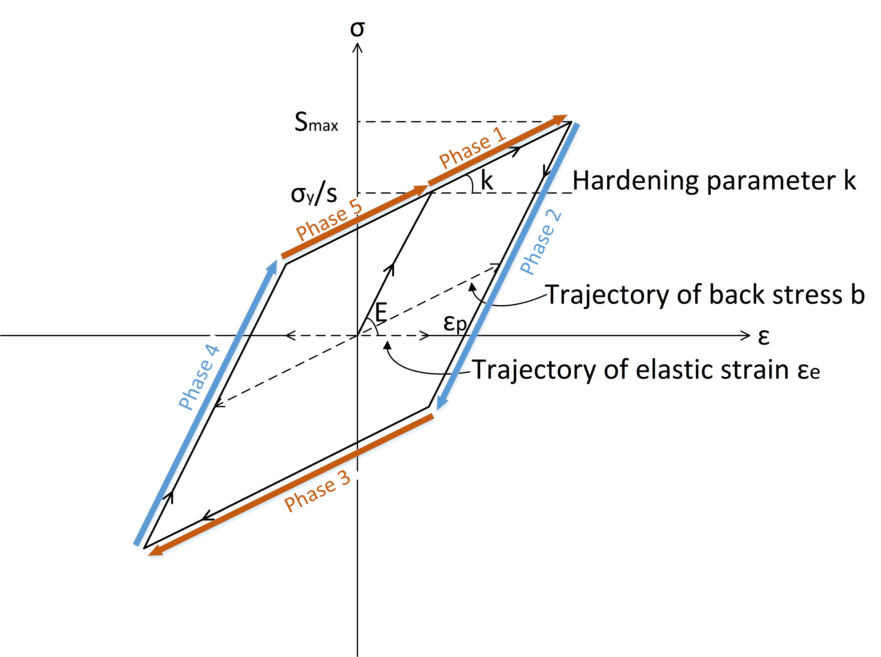

Figure 2: Uniaxial load with plastic dissipation

In phase 1, a direct analysis yields the energy dissipation at scale :

 (3)

A similar analysis yields



We can calculate local dissipated energy  at point  during one cycle by cumulating the input of all sub-scales with their probabilities [4].

 (4)

If the damage measured by the dissipated energy accumulates linearly until a failure value , we can get directly the time to failure from Eq.(5):

 (5)

From Eq.(4), we then obtain that the model predicts as expected a power law dependence in function of . However, experiments shows that the damage or the energy accumulation of a material evolves non-linearly in time. We should introduce below a method to give the nonlinearity.

## 4 Nonlinearity of damage accumulation

### 4.1 Energy approach with Chaboche law

The Chaboche law[2] is essentially a damage incremental law for cyclic loading of stress intensity  with a deviatoric part  and hydrostatic part , defining the damage increase by:

 (6)

which writes equivalently as Eq.(7)

 (7)

Here  denotes the number of cycles at intensity  to failure as obtained by integration of Eq.(7) from  to .

In our model, in case of a simple uniaxial cyclic loading, we propose to replace  which is the relative unit increment of cycles by , yielding the nonlinear damage incremental law:

 (8)

This is a nonlinear law but with a constant , there will be no sequence effect. In other words, when applying two successive cycles of different intensities, the failure will occur at the same number of cycles whatever the order of the loading(high then low versus low then high).

### 4.2 Generalized damage accumulation

Formula (7) is a general accumulation law which can be applied for any cyclic loading period that we can identify the multiscale value of the dissipated energy per cycle.

But the notion of cycle itself may be hard to identify for general loadings. The idea is then to replace the relative increment of dissipated energy per cycle by the relative increment of dissipated energy per unit time, yielding:

 (9)

In a general loading case,  is to be computed. By integrating Eq.(2) over all microscales, we get:

 (10)

The evolution of ,  and  are given in section 1.4. Equation (9) and (10) are therefore our proposed damage law.

## 5 Loop on time and scales

### 5.1 Integration rules for and

Our first approach takes unit of time in one cycle. We compute analytically energy dissipation at each scale during this cycle. The method is valid for simple loading history which includes the integration on all weakening scales. The damage  is accumulated after each cycle.

However, there are certain limitations of this method. Firstly we need a load history decomposition in cycles. Secondly in real life the perfect close loop cycle is hardly applicable.

Thus we propose in Eq.(9) a more general method which can be integrated by a step by step strategy. We compute numerically the dissipation at different scales using an implicit Euler time integration of the constitutive laws of section 1.4. After which we make a numerical integration on different scales. Then we can update the damage and go to next time step.

Instead of doing the scale integration directly which can be difficult for complex loading, the Gaussian Quadrature rule with Legendre points is used to give the value of local dissipated energy rate.

To use the Gaussian quadrature rule the limit range of integral must be from  to , while the total dissipated energy is expressed by integrating all the weakening scale  ranging from 1 to infinity with their occurrence probabilities:



To change the limit range of integral from  to  we set  with , yielding  and  with



that is



Therefore the dissipated energy at all scales is like Eq.(11):

 (11)

if we set .

So the dissipated energy rate integrated over all scales takes the form of Eq.(12):

 (12)

where  and  are respectively the weights and nodes of the Gauss Legerndre integration rule used for the numerical integration. In this work, we used 25 points[5].

After changing the integration limit,  represents the scale .

Damage accumulation is deduced from Eq.(9):

 (13)

with .

We upgrade the damage step by step following Eq.(13). When  reaches unit, the material fails.

### 5.2 Regime determination under multiple scales

The material could be both in elastic and plastic regime under different scales. To be more elaborate, we reuse the fundamental equations in different regimes. At scale , we have a dissipation rate given by:



which differs between a plastic and an elastic regime.

**Elastic regime:**

There we have ,  and , so



yielding

 (14)

We are in elastic regime as long as we satisfy



**Plastic regime:**

When we leave elastic regime at scale s, we have:

In unidimensional case we could use the multiple phase method to express the dissipated energy. In multi-dimensional case  which is the hydrostatic stress and we need a more general expression.

In all cases, we get(see annex ’Multi-dimensional analysis’)

 (15)

with





That is to say, when the structure is in elastic regime at time  and scale , . Otherwise, if the absolute value of  is greater than the local yield limit ,  will be on the yield limit.

Knowing the distinction between elastic and plastic regime under multiple scales, we compute the general expression of the dissipated energy rate.

 (16)

From Eq.(24) and Eq.(27) in annex, we get:

 (17)

where   is Macaulay bracket symbol.   is defined as  if .

We replace  deduced from Eq.(17) in Eq.(16) to give the expression of local energy dissipation rate at scale :

 (18)

With Eq.(12), the final expression of energy dissipation W during time step dt writes:

 (19)

We have the damage accumulation deduced in Eq.(13):



with 

Now we are able to put these formula into numerical tests.

## 6 Test on different load histories

### 6.1 One dimensional application to simple cyclic data

The test is first performed on a sinusoidal axial load  with parameters in Table.1.

|  |  |
| --- | --- |
| **Parameters** | **Value** |
| Load | Pa |
| Young’s modulus | Pa |
| Hardening parameter | Pa |
| Weakening scales distribution exponent |  |
| Hydrostatic pressure sensitivity |  |
| Macroscopic yield stress | Pa |
| Mean stress | Pa |
| Material parameter from Chaboche law(Wohler curve exponent) |  |
| Initial damage |  |
| Initial time | s |
| Dissipated energy to failure per unit volume | J |
| Looping step | s |

Table 1: Material parameters a simple cyclic load

We use matlab to realize our analytical method. We plot  and  for two different scales( and ) in 3 .

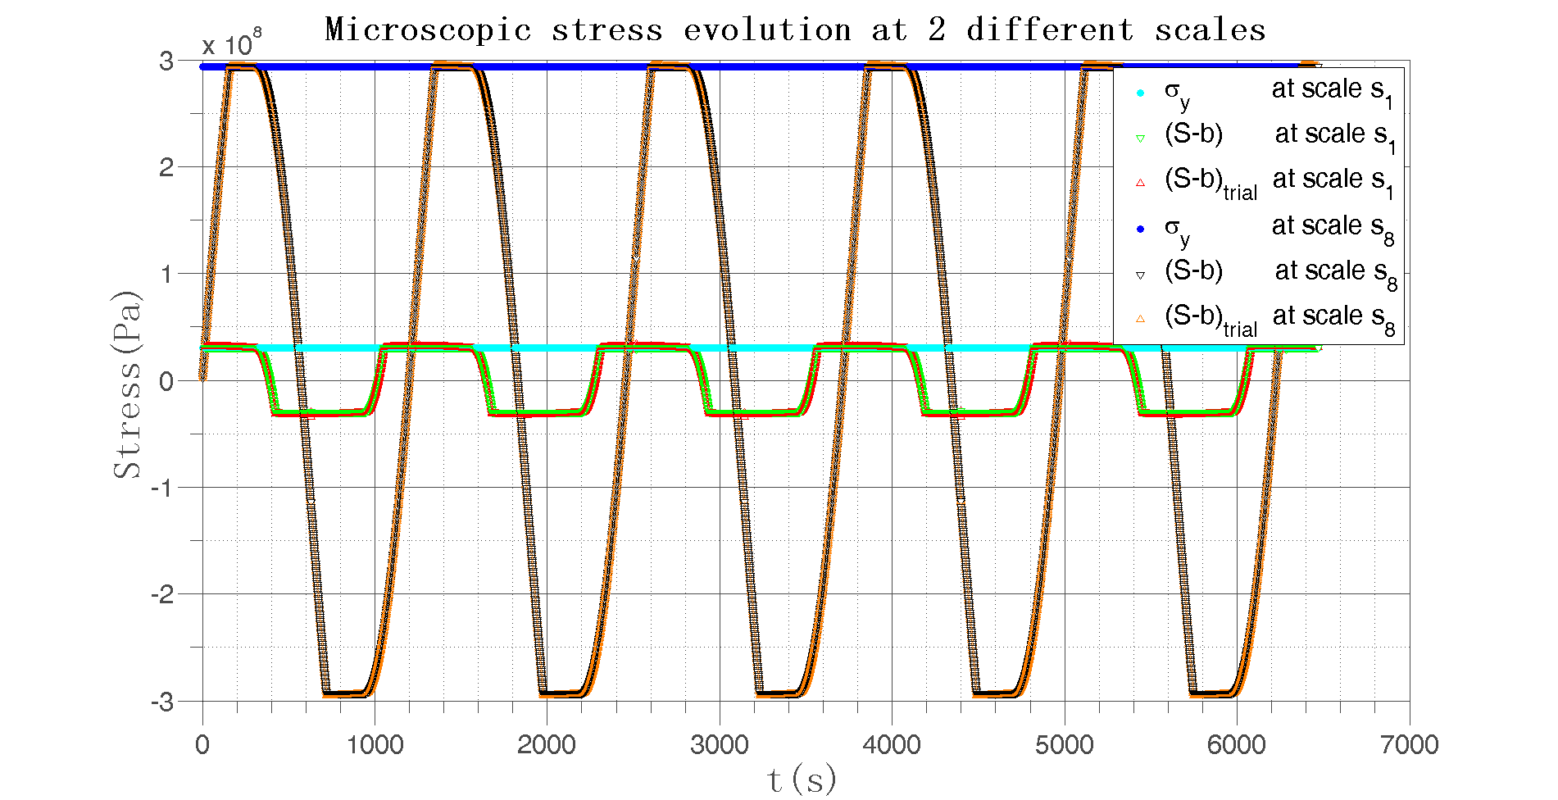

Figure 3: Microscopic  and  evolution with time under different weakening scales in sinusoidal load

The nonlinearity is determined by  which is predominated by Crossland criterion. The damage evolves like in 4 , where we compare the damage evolution as predicted by the cycle accumulation Eq.(4) and by the numerical strategy of section 4.

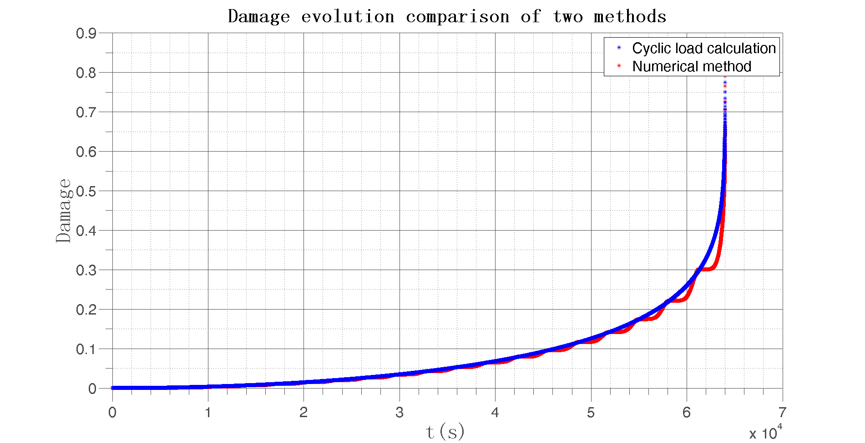

Figure 4: Damage evolution with time under sinusoidal load with two different methods

Now we compare the result to the one demonstrated in 2 . The first cycle has 3 phases which have the energy loss identical to phase 1. The following cycles each have 4 times energy loss as phase 1. When damage reaches unit, we can make a comparison between multiple phases and analytical method. The cyclic load calculation is only valid for very simple such as proportional loading in fatigue, nevertheless it can still be used as a comparison group to verify the numerical results. The outcome seems satisfactory. Hence, to be more general for any loading history, we adopt the numerical method.

### 6.2 One dimensional application to PSA data

In this test, we reconstruct a unidimensional macroscopic stress history from recorded force data proposed by PSA group.

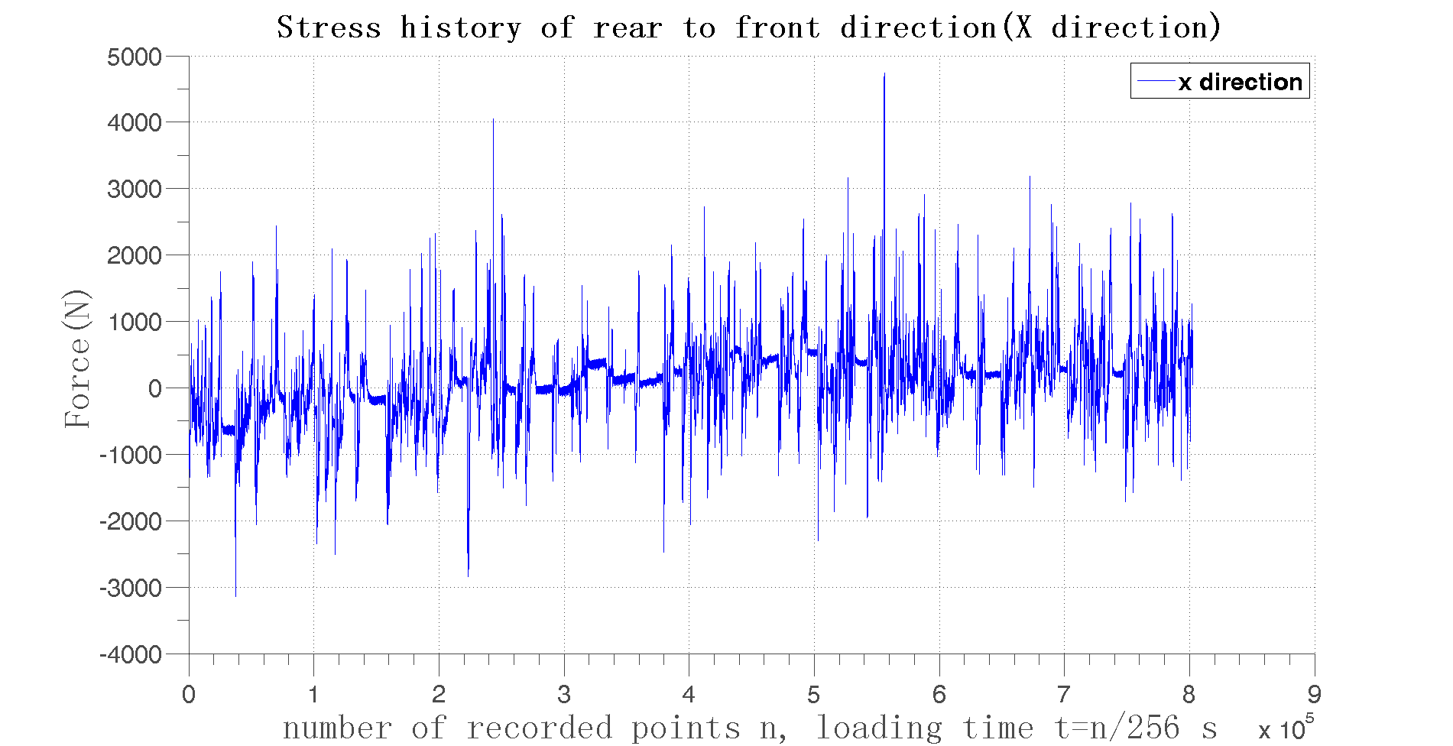

Figure 5: Loading history of X direction, force vs the record index n, with 256 sample recorded per second

The sample recording rate is 256 per second. In order to accumulate damage using very small steps, we have created 10 additional points between every 2 recorded points by linear interpolation. So the sample rate is  per second.

The force on wheel is firstly considered as under uniaxial loading . Here we temporally set  where  is the area of force, and . The other data are as Table.1. The plot of  and  under 2 different scales( and ) are shown in 6 .

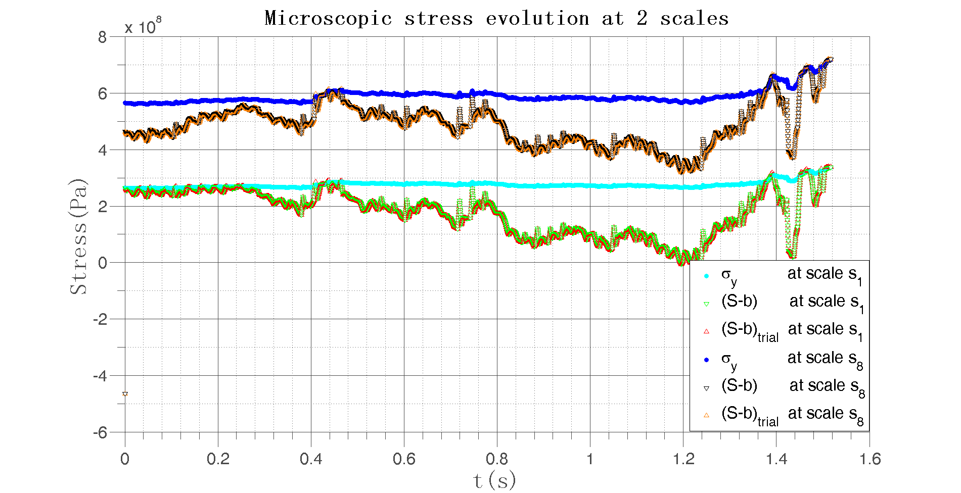

Figure 6:  and  evolution with time under different weakening scales in PSA load history

### 6.3 Multi-dimensional application to PSA data

We now consider a situation where we have force recorded measured in 3 different directions as shown in 7 .

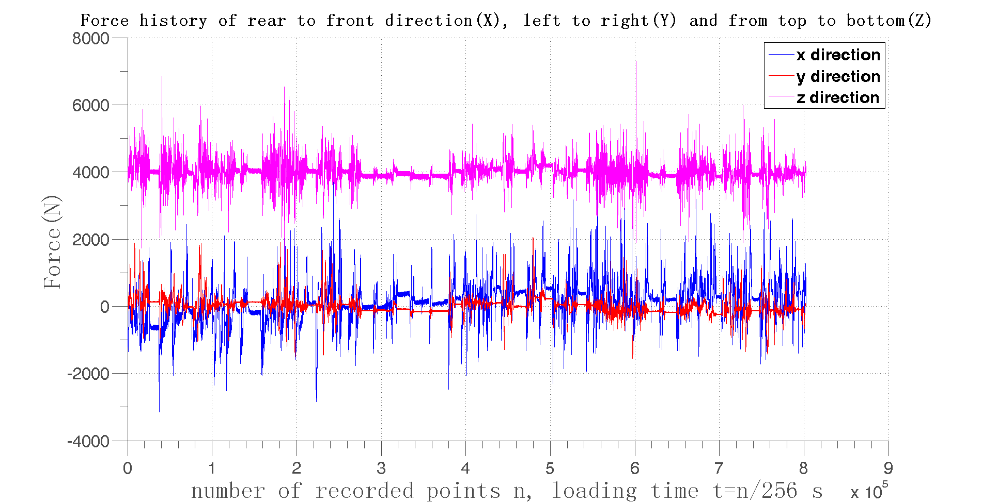

Figure 7: Loading history of 3 different directions

In real case, the vertical force  is much larger than the axial and horizontal forces  and , as shown in 7 . However, in order to investigate large domains of interest, we first scale the axial and horizontal forces to reach comparable impact and transform them in principal stresses  applied along the stress principle vector (respectively ) that we choose randomly. We therefore consider the following macroscopic stress tensor:

 (20)

where  and  are principal vectors whose spherical coordinate are  and , respectively  and :





Here , ,  are from test data, and , , ,  are structural parameters to be chosen randomly.The physical data are the same with parameters in Table.1. The structural data we choose is shown in Table.2.

|  |  |  |  |  |  |  |  |
| --- | --- | --- | --- | --- | --- | --- | --- |
| **Parameters** | A() |  |  |  |  |  |  |
| **Value** | 1/6e4 | 10 | 60 | 0.5 | 0.3 | 0.6 | 0.4 |

Table 2: The structural data in 3D analysis

The underlying assumption is that a unit load on wheel in direction  creates a stress tensor at point  given by:



where  defines the local structural response of the vehicle.

Replacing  and  in Eq.(20) we get the stress tensor in Eq.(??) in the annex.

The plot of  and  under 2 different scales( and ) are shown in 8 .

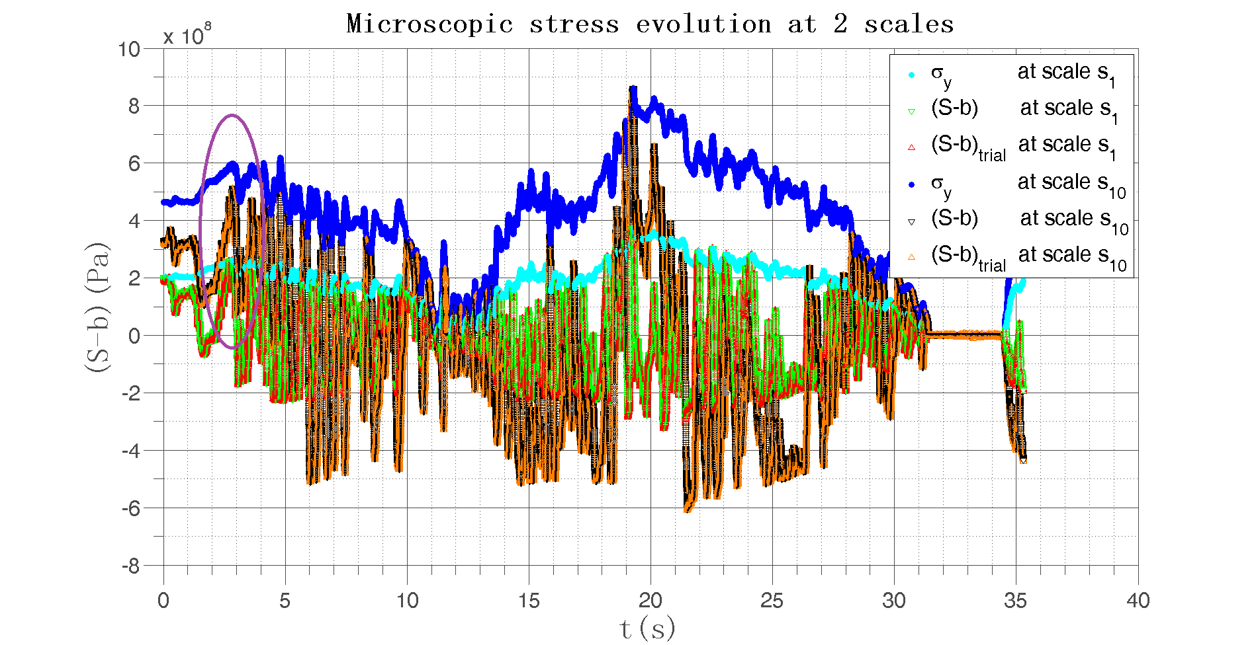

Figure 8:  and  evolution with time under different weakening scales in PSA load history

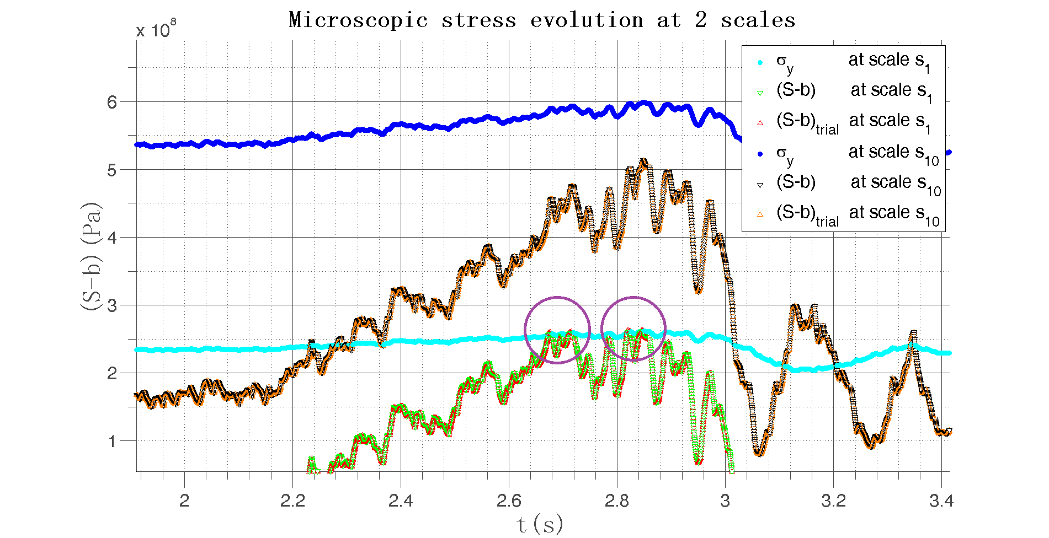

Figure 9: Circled area magnification in 8 where in the circled area there is 

In the load history, when , the damage accumulates. However, under scale , there are much less damage accumulation than under scale , as shown in ?? and the circles in 9 . In this way we do not neglect the small influences in load history and the big fluctuation in stress is magnified which reflects the real situation.

The damage evolves like in 10 .

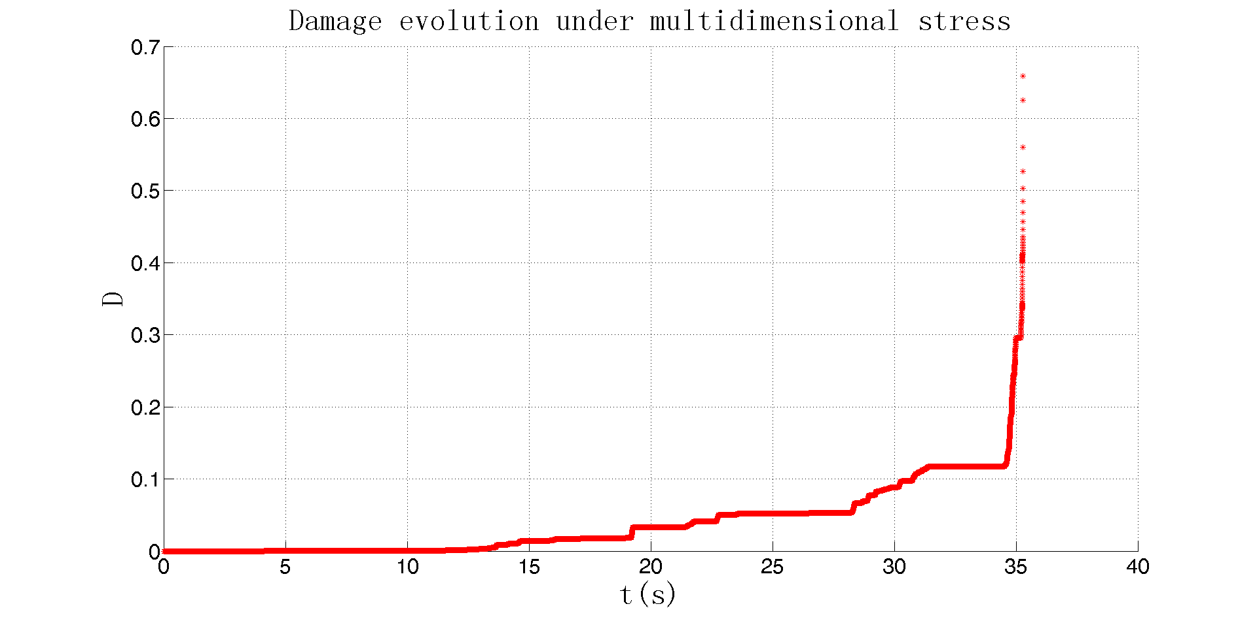

Figure 10: Damage evolution under multidimensional stress

We can improve the result by inserting more arithmetic sequence points between every 2 recorded points. As is shown in Tab.3 :

Table 3: Arithmetic sequence points density effect

|  |  |
| --- | --- |
| **Arithmetic sequence points between every two points** | **Total time to failure(s)** |
|  | 78.63711 |
|  | 72.24630 |
|  | 70.25793 |
|  | 68.69148 |
|  | 67.49223 |

## 7 Discussion

The strategy can be made more complex by introducing a local space averaging process in the calculation of the local damage, and by taking more general plastic flows. The energy based fatigue approach takes into account impurities and hardness in the material which affect the fatigue life. The load sequence effects for complex multiaxial loading history are included in damage accumulation process. The small step-by-step strategy does not ignore small fluctuations in the load history. In addition, it can take into account any type of micro plasticity law and multiaxial load geometry.

Further research of energy based failure criteria should be focused on the following aspects:

1. The accommodation law might be more elaborate than kinematic hardening.

2. The differentiation of shear stress and normal stress effect on fatigue life should be clarified.

3. The non-linearity parameter  contains the stress , so it can evolve with time. But for complex loading history, should it change at every time step?

**Acknowledgments**

We are grateful for the financial and technical support of Chaire PSA.

**References**

[1] Stefano Bosia and Andrei Constantinescu. Fast time-scale average for a mesoscopic high cycle fatigue criterion.  *International Journal of Fatigue*, 45:39 – 47, 2012.

[2] Jean Lemaitre and Jean-Louis Chaboche.  *Mechanics of solid materials*. Cambridge university press, 1990.

[3] M.H. Maitournam, C. Krebs, and A. Galtier. A multiscale fatigue life model for complex cyclic multiaxial loading.  *International Journal of Fatigue*, 33(2):232 – 240, 2011.

[4] Ma Zepeng. Structures under multiaxial fatigue taking consideration of gradients of the constraints with time and space variation.

[5] Legendre Gauss Quadrature weights and nodes. https://www.mathworks.com/matlabcentral/fileexchange/4540-legendre-gauss-quadrature-weights-and-nodes. Accessed: 2004-05-11.

Appendix

basicstyle=, keywordstyle=, identifierstyle=, commentstyle=, stringstyle=, showstringspaces=false ************************************************************************************

Multi-dimensional analysis

************************************************************************************

At a certain scale , after elimination of , there are



If we are at yield limit at (t+dt), we get on the other hand:



 (21)

Replacing  in the integration by its expression we get:

 (22)

Putting all terms with  on the left hand side, we get:

 (23)

with

 (24)

To see whether the structure is in elastic or plastic regime at each time step, we use  to compare with the yield stress at the same scale , thus to give a value to .

Since  is in the same direction as .

 (25)

We now compare Eq.(23) and Eq.(25), the only solution is to have:

 (26)

that is:

 (27)

which is positive in plastic regime.